Benefits of immunization
Immunization is one of the most important accomplishments in public health that has, over the past 50 years, led to the elimination, containment and control of diseases that were once very common in Canada. Before vaccines became available, many Canadian children were hospitalized or died from diseases such as diphtheria, pertussis, measles and polio. Today, although these disease-causing bacteria and viruses still exist, such diseases are rarely, and in some cases (such as polio) never seen in Canada. However, if vaccination was reduced or stopped, diseases controlled through immunization would re-appear in Canada. This phenomenon has been observed in other countries where large epidemics occurred following a decline in immunization rates, resulting in many preventable hospitalizations and deaths.
Immunization is important in all stages of life. Infants and young children are particularly susceptible to vaccine preventable diseases because their immune systems are less able to fight infection; as a result, they require timely immunization. Older children and adults also require immunization to restore waning immunity and to build new immunity against diseases that are more common in adults.
Immunization directly protects individuals who receive vaccines. Through community (or herd) immunity, immunization against many diseases also prevents the spread of infection in the community and indirectly protects:
- newborns who have not yet received all of their vaccines
- people who cannot be vaccinated for medical reasons, such as people who had an organ transplant or are undergoing treatment for cancer or other illnesses
- people who may not adequately respond to immunization such as the elderly

Epidemiology and immunization
Epidemiology provides data on the distribution and determinants of diseases. Epidemiology informs the first steps in vaccine development by describing the diseases caused by a pathogen in a particular population and indicating the need for vaccine development. As a vaccine is introduced into the population, epidemiology monitors the effect of the vaccine in the population by describing changes in the disease burden and the pathogens causing that disease. Epidemiology can also provide information regarding immunization coverage and vaccine safety.
Surveillance is the process of systematic collection, orderly analysis, evaluation and reporting of epidemiological data to inform disease control measures or policy decisions, or both. Surveillance of vaccine preventable diseases, including immunization coverage and vaccine safety, is needed to:
- identify and quantify risk factors to enable appropriate control of communicable diseases
- assist in the investigation, containment and management of vaccine preventable disease outbreaks or a signal of adverse events following immunization
- monitor progress toward the achievement of set goals and targets in disease control programs
- provide up-to-date information to assist in the development of evidence-based guidelines
Determining the burden of disease is important in setting immunization priorities. Burden of disease includes: the prevalence (total number of cases of a disease in a geographic area); the incidence (number of new cases of a disease in a geographic area over a specified period of time); the age or risk group that is most affected (for example, infants, children, adults, the elderly, immunocompromised persons); the severity of the disease (for example, as measured by time missed from work, hospitalization, complications or death); and the risk factors for disease that should be considered. These factors are particularly important when making vaccine recommendations regarding:
- populations who are susceptible to the disease and who require the direct protection of a vaccine
- populations who require indirect protection through herd immunity because they are susceptible to the disease but may not be the ideal target group to receive the vaccine.
Evaluation of vaccine programs is the systematic investigation of the structure, activities, or outcomes of public health programs. It explores whether or not activities are implemented as planned and outcomes have occurred as intended, and why. Evaluation can help to support program implementation and build on the program monitoring activities that immunization programs currently conduct to assess whether program objectives have been met.
Figure 1. Incidence rates (cases per 100,000 population) of reported measles cases, Canada, 1950 to 2022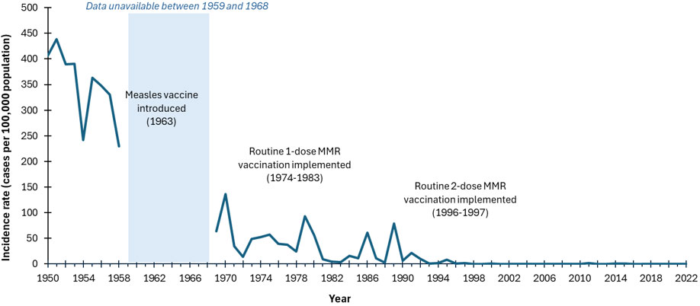
Abbreviation:
MMR = measles-mumps-rubella vaccine
Figure 1: Text Equivalent
This image includes a graph showing the incidence rates (cases per 100,000 population) of reported measles cases in Canada over time. On the graph, the x axis represents the time between 1950 and 2022. The y axis represents measles incidence rates per 100,000 population, starting with 0 at the bottom to 500 at the top. The blue line representing the reported incidence rate of measles shows a decline from a peak of 439 cases per 100,000 population in 1951 to 16 cases per 100,000 by 1984, following the introduction of the measles vaccine in 1963 and the routine 1-dose MMR vaccination between 1974 and 1983 (note: measles was not notifiable between 1959 and 1968). After a few fluctuations, the rate declined from 16 cases per 100,000 population in 1984 to less than 0.1 cases per 100,000 by 2022, following the introduction of the routine 2-dose MMR vaccination between 1996 and 1997. This figure effectively illustrates the impact of vaccination programs on reducing measles cases over time.
Figure 2. Incidence rates (cases per 100,000 population) of reported pertussis cases in Canada by year, 1938 to 2022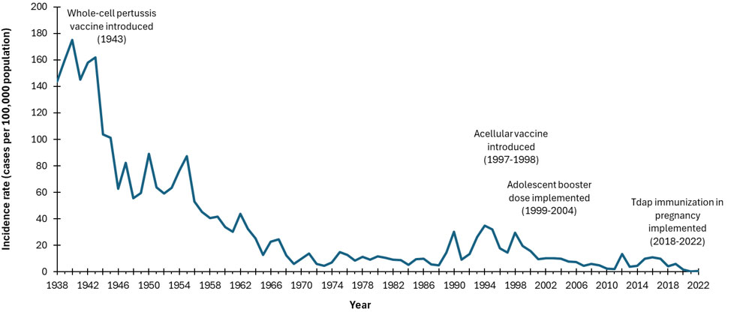
Abbreviation:
Tdap = Tetanus, diphtheria, and acellular pertussis
Figure 2: Text Equivalent
This image includes a graph showing the incidence rates (cases per 100,000 population) of reported pertussis cases in Canada over time. On the graph, the x axis represents the time period between 1938 and 2022. The y axis represents pertussis incidence rates per 100,000 population, starting with 0 at the bottom and going up to 200 at the top. The blue line representing the incidence rate of pertussis shows a decline from a peak of 180 cases per 100,000 population in 1940 to 4.9 per 100,000 by 1988, following the introduction of the whole-cell pertussis vaccine in 1943. After a few fluctuations, the incidence rate declined further from 14.9 cases per 100,000 population in 1989 to 0.5 per 100,000 by 2022, after the acellular vaccine was introduced in 1997-1998, adolescent booster doses were given between 1999-2004, and Tdap vaccination during pregnancy was implemented. This figure effectively illustrates the impact of vaccination programs on reducing pertussis cases over time.

Value for money of vaccines
Vaccine preventable diseases result in significant costs to individuals who fall ill, caregivers, the health system (healthcare system and public health system), and society, including costs associated with absenteeism from work or school, visits to health care providers, hospitalizations, and premature deaths. In addition to being one of the most beneficial, immunization is also one of the most cost-effective public health interventions.
Historically, many immunization programs compare very favourably to other interventions, providing savings to the health system and to society more broadly (refer to Table 2). Savings to the health system can be seen when the cost of implementing the immunization program is less than the cost of treating the illness that would occur if the program was not implemented. Benefits to society more broadly include productivity gains such as through improved cognition, physical strength, educational achievement, attendance in school and work, among other benefits. In the context of low- and middle-income countries, for every $1 invested in immunization programs, there are an estimated $20 to $52 in savings. In the United States, for every US$1 invested in childhood immunization programs, there are an estimated US$10 in savings. In the context of health emergencies such as that of the coronavirus disease 2019 (COVID-19) pandemic, the tremendous, negative health and economic impacts that extend to every area of the economy can be reduced through immunization. In Canada, the costs of COVID-19 pandemic immunization were far outweighed by the savings to society associated with the prevention of infections and premature deaths (estimated net benefit of $298.1 billion). Because immunization with these vaccines maintains health and results in cost savings, the decision to include these vaccines in publicly funded immunization programs is straightforward.
immunization programs.

Acknowledgements
This chapter revision was prepared by S Pierre, MW Yeung, AR Tuite on behalf of NACI and D Bhagat, S David, A Kodua, and S Rajakumar on behalf of the Centre for Emerging Respiratory Infections and Pandemic Preparedness.
PHAC gratefully acknowledges the contribution of SH Lim, N Haddad and C Jensen.

Selected references
- Leidner AJ, Murthy N, Chesson HW, Biggerstaff M, Stoecker C, Harris AM, Acosta A, Dooling K, Bridges CB. Cost-effectiveness of adult vaccinations: A systematic review. Vaccine. 2019 Jan 7;37(2):226-34.
- Public Health Agency of Canada (PHAC). Reported cases from 1924 to 2022 in Canada — notifiable diseases on-line. [Internet]. Ottawa (ON): Government of Canada; 2022 [cited 2024 Oct 24] Available at: https://diseases.canada.ca/notifiable/charts?c=pl
- Public Health Agency of Canada (PHAC). Measles and Rubella Weekly Monitoring Reports. [Internet]. Ottawa (ON): Government of Canada; 2024 [cited 2024 Oct 24] Available at: https://www.canada.ca/en/public-health/services/diseases/measles/surveillance-measles/measles-rubella-weekly-monitoring-reports.html
- Public Health Agency of Canada (PHAC). National Advisory Committee on Immunization (NACI): Guidelines for the economic evaluation of vaccination programs in Canada [Internet]. Ottawa (ON): Government of Canada; 2023 Aug 02 [cited 2024 Feb 05]. Available from: https://www.canada.ca/en/public-health/services/immunization/national-advisory-committee-on-immunization-naci/methods-process/incorporating-economic-evidence-federal-vaccine-recommendations/guidelines-evaluation-vaccination-programs-canada.html
- Public Health Agency of Canada (PHAC). National Advisory Committee on Immunization (NACI): Interpretation Guide - Health Economics [Internet]. Ottawa (ON): Government of Canada; 2024 Mar 18 [cited 2024 Mar 20]. Available from https://www.canada.ca/en/public-health/services/immunization/national-advisory-committee-on-immunization-naci/methods-process/interpretation-guide-health-economics.html
- Public Health Agency of Canada. (PHAC). Measles: Health professionals [Internet]. Ottawa (ON): Government of Canada; 2024 [cited 2024 Oct 24]. Available from https://www.canada.ca/en/public-health/services/diseases/measles/health-professionals-measles.html#s10
- Sim SY, Watts E, Constenla D, Huang S, Brenzel L, Patenaude BN. Costs of immunization programs for 10 vaccines in 94 low- and middle-income countries from 2011 to 2030. Value Health. 2021 Jan;24(1):70-77.
- Tengs TO, Adams ME, Pliskin JS, Safran DG, Siegel JE, Weinstein MC, Graham JD. Five-hundred life-saving interventions and their cost-effectiveness. Risk Anal. 1995 Jun;15(3):369-90
- Tuite AR, Ng V, Ximenes R, Diener A, Rafferty E, Ogden NH, Tunis M. Quantifying the economic gains associated with COVID-19 vaccination in the Canadian population: A cost-benefit analysis. Can Commun Dis Rep 2023;49(6):263-73.
- Zhou F, Shefer A, Wenger J, Messonnier M, Wang LY, Lopez A, Moore M, Murphy TV, Cortese M, Rodewald L. Economic evaluation of the routine childhood immunization program in the United States, 2009. Pediatrics. 2014 Apr;133(4):577-85.

Page details
Date modified:
2025-07-24

